**UNIVERSITY REGISTER OFFICE:**

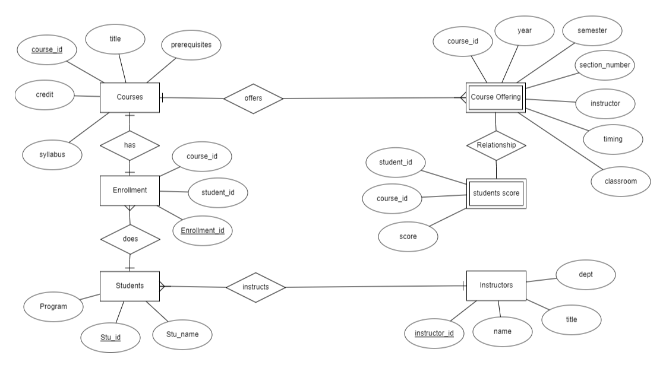

In this ER diagram we can infer that Instructor instructs the students and the student takes up the courses and the course offers the course offering.

**UNIVERSITY REGISTER OFFICE TERNARY:**

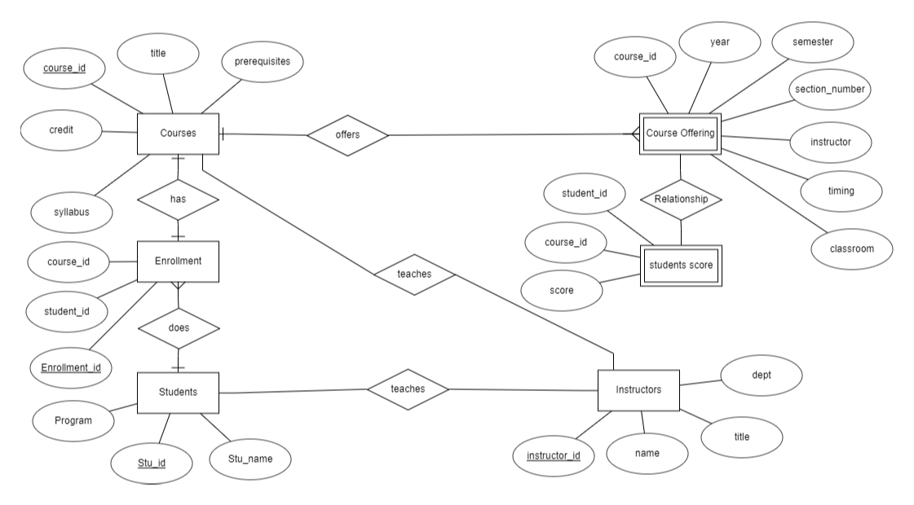

From this ER diagram we can infer that instructor teaches students , instructor als0 teaches courses

So that student enrolls courses and course offers course offering